**BRISK VEHICLE RENTAL SERVICES**

**A Final Output for Dynamic Web Application & Tools (6DWEBTOOLS)**  
**Presented to the Faculty of the School of Computing**  
**Holy Angel University**  
School Year 2022 - 2023



Submitted to:  
**Prof. CHRIS ALMOCERA**

Submitted by:  
**ENRIQUEZ, JUAN MIGUEL T.**  
**JACULBIA, KENJI P.  
MANIAGO, CHARMAGNE DALE G.  
MEDINA, DARYLL TIMOTHY**

Section:  
**WD-20**

April 2023

Table of Contents

List of Tables

List of Figures

(header & page 1 must start on the next page)

**Website Name:** BRISK VEHICLE RENTAL SERVICES

**DOCUMENTATION** (Images below are Samples Only. Download this document to insert your contents)

**WEBSITE DESCRIPTION & PURPOSE**

**Objectives**

We are the Brisk Vehicle Rental Services, an online platform that provides customers with reliable and comfortable vehicles for short-term rentals. Our website was created to help those who don't have access to their own vehicles or who may not have a car in good condition. As a team, we are dedicated to offering a safe and secure rental experience, where customers can trust the vehicles, they rent and have a comfortable journey.

Our focus is to make renting a vehicle easy and stress-free for tourists who want to explore Pampanga, Philippines. Our services are particularly helpful for those who find it challenging to navigate the local transportation system, especially for foreigners. By providing a wide range of well-maintained vehicles, we aim to make it more convenient and comfortable for our customers to discover Pampanga and the surrounding areas.

We offer several benefits, including competitive pricing, various vehicle options to choose from, flexible rental periods, and a straightforward rental process. Our priority is the safety and condition of our vehicles, ensuring that they are always roadworthy and reliable for our customers. Our ultimate goal is to provide a comfortable and enjoyable rental experience, where customers can enjoy their travels without worrying about the quality or reliability of their vehicle.

**Features and functionalities of the website**

As a part of the Brisk Vehicle Rental Services team, I am proud to say that our website provides several features that make renting a vehicle a seamless and hassle-free experience for our customers. Here are some of the features that we offer:

1. Simple and user-friendly interface: Our website has a clean and easy-to-use interface, providing clear information about rental options, pricing, and vehicle availability. We understand the importance of a simple and user-friendly website, which is why we have designed our interface with ease-of-use in mind.

2. Online booking system: We offer an online booking system that makes it easy for customers to secure a rental without visiting a physical location. This feature is especially helpful for those who may not have the time to visit us in person, or those who prefer to make their reservations from the comfort of their own home.

3. Availability calendar: Our website has a calendar feature that displays the availability of vehicles on specific dates. This helps customers plan their rentals around their travel schedule, ensuring that they can secure the vehicle they need for their trip.

4. Vehicle selection: We provide a wide selection of vehicles, with clear information about each vehicle's specifications, features, and rental price. This allows customers to choose the vehicle that best fits their needs and budget.

5. Rental period flexibility: We understand that not everyone's rental needs are the same, which is why we offer rental periods that are flexible and customizable. Whether customers need a vehicle for a day, a week, or longer, we can accommodate their specific needs.

6. Customer support: Our customer support team is always available to assist customers with any questions or concerns they may have. We understand that renting a vehicle can be stressful, which is why we strive to make the rental process as smooth and easy as possible for our customers.

**Benefits of the website**

We are pleased to share with you the several benefits that we offer to our valued customers. Here are some of the advantages that we provide:

1. Convenience: We understand that owning a vehicle can be a long-term commitment and expense. With Brisk Vehicle Rental Services, customers can rent a vehicle for a short amount of time, without the stress and expense of owning a vehicle. This convenience is especially useful for those who only need a vehicle for a specific period, such as tourists or those who are traveling for work.
2. Variety of vehicles: We offer a wide selection of vehicles, from small cars to larger vans or trucks, to meet the specific needs of our customers. Whether you need a compact car for city driving or a larger vehicle for a family road trip, we have options available to meet your needs.
3. Competitive pricing: Our rental services come with competitive pricing, making it an attractive option for those who need a vehicle for a short amount of time. We strive to offer affordable prices without compromising the quality of our vehicles.
4. Flexible rental periods: At Brisk Vehicle Rental Services, we understand that not everyone's rental needs are the same. That's why we offer flexible rental periods, whether it's for a day, a week, or even longer. Our rental periods can be customized to meet the specific needs of our customers.
5. Easy rental process: We pride ourselves on providing a straightforward and user-friendly rental process. Our website provides clear information about pricing, vehicle options, and rental periods, making it easy for our customers to rent a vehicle with just a few clicks.

**LOGIN INFO FOR WEBSITE** (Tabular)

| Username | Password |
| --- | --- |
|  |  |
|  |  |
|  |  |
|  |  |
|  |  |

**WEBSITE STRUCTURE**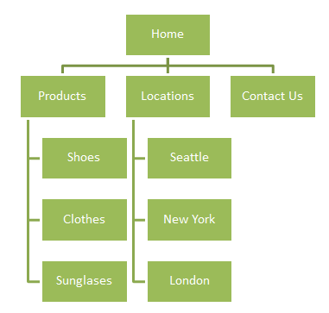

**BRANDING/BRAND KIT**

**WIREFRAMES & MOCKUPS (Web Layout)**

(Wireframes and Mockups shall face each other with label for every page you will have in your site.)

**ACTUAL WEBSITE SCREENSHOTS**

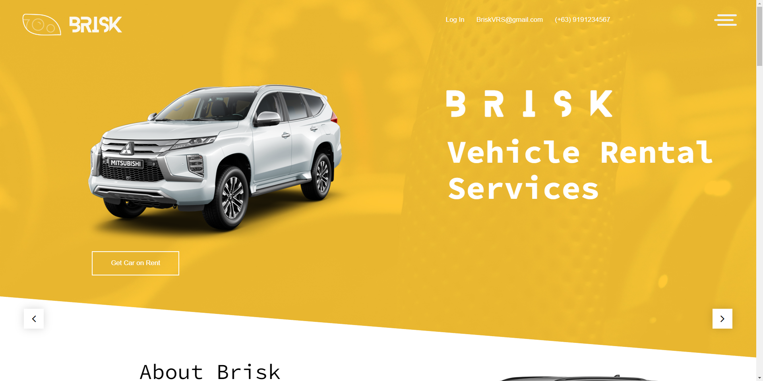

**BUSINESS RULES FOR DATABASE**

* Each car in the tblCar table must have a unique car_id value.
* The tblAvailability table tracks the availability of cars for rental during specific time periods, as indicated by the start_date and end_date fields. The available field is a flag indicating whether the car is available during that time period (1 = available, 0 = not available).
* Customers can make reservations for available cars by providing their user_id, the car_id of the car they wish to rent, and the pickup and return dates/times in the tblReservation table.
* The rental_days field in tblReservation indicates the number of days the customer wishes to rent the car.
* The total_cost field in tblReservation should be calculated as the rental_days multiplied by the daily_rate of the car rented.
* The reservation_date field in tblReservation should be automatically populated with the date/time when the reservation was made.
* Each user in the tblUser table must have a unique user_id value.
* Each user in the tblUser table must have a unique username value.
* Each user in the tblUser table must have a unique email value.
* The tblLogin_credential table is used to store login credentials for users, including their username, password, and email. Each user should have a corresponding row in the tblLogin_credential table with a foreign key referencing their user_id.
* The password field in tblLogin_credential should be encrypted to ensure security of customer data.
* The daily_rate field in tblCar should not be null, as this is used to calculate the total cost of rentals.

**ENTITY RELATIONSHIP DIAGRAM (ERD)**

**DATA DICTIONARY OF DATABASE TABLES**

| tblAvailability | | | | |
| --- | --- | --- | --- | --- |
| Field Name | **Data Type** | **Field Length** | **Constraint** | **Description** |
| availability_id | int |  | PK, AI | Unique availability identifier |
| car_id | int |  | FK(Car.car_id) | Car identifier |
| start_date | datetime |  |  | Start date of availability period |
| end_date | datetime |  |  | End date of availability period |
| available | tinyint |  |  | Flag indicating if car is available during period (0 = not available, 1 = available) |

| tblLogin_credential | | | | |
| --- | --- | --- | --- | --- |
| Field Name | **Data Type** | **Field Length** | **Constraint** | **Description** |
| user_id | int | PK | FK(User.user_id) | Unique identifier for login credential with foreign key to user table. |
| username | varchar | 50 | NN | Username for login credential. |
| password | varchar | 255 | NN | Encrypted password for login credential. |
| email | varchar | 255 | NN | Email address for login credential. |

| tblReservation | | | | |
| --- | --- | --- | --- | --- |
| Field Name | **Data Type** | **Field Length** | **Constraint** | **Description** |
| reservation_id | int |  | PK, AI | Unique reservation identifier |
| user_id | int |  | FK(User.user_id) | User who made the reservation |
| car_id | int |  | FK(Car.car_id) | Car that was reserved |
| pickup_date | datetime |  | NN | Date and time of car pickup |
| return_date | datetime |  |  | Date and time of car return |
| rental_days | int |  |  | Number of days rented |
| total_cost | decimal | 10,2 |  | Total cost of rental |
| reservation_date | datetime |  |  | Date and time when the reservation was made |

| tblUser | | | | |
| --- | --- | --- | --- | --- |
| Field Name | **Data Type** | **Field Length** | **Constraint** | **Description** |
| user_id | int |  | PK, AI, NN | Unique user identifier |
| username | varchar | 50 | Unique, NN | Username for login |
| password | varchar | 255 | NN | Password for login |
| email | varchar | 255 | Unique, NN | Email address for login |
| first_name | varchar | 50 | N | User's first name |
| last_name | varchar | 50 | N | User's last name |
| phone | varchar | 20 | N | User's phone number |
| address | varchar | 255 | N | User's address |

| tblCar | | | | |
| --- | --- | --- | --- | --- |
| Field Name | **Data Type** | **Field Length** | **Constraint** | **Description** |
| car_id | int |  | PK, AI, NN | Unique car identifier |
| brand | varchar | 50 |  | Car's brand |
| model | varchar | 50 |  | Car's model |
| year | int | 4 |  | Car's year of manufacture |
| car_type | varchar | 50 |  | Car's type (e.g. sedan, SUV, etc.) |
| transmission | varchar | 50 |  |  |
| engine | varchar | 50 |  |  |
| seat | int | 2 |  |  |
| daily_rate | decimal | 10,2 | NN | Cost of renting car per day |

**NORMALIZATION OF TABLES**

| **tblAvailability** (AvailabilityID (PK), CarID (FK to Car.CarID), StartDate, EndDate, Available) |
| --- |

| **tblLogin_credential** (UserID(PK), Username, Password, Email) |
| --- |

| **tblReservation** (Start_date, Return_date, No_of_Days, UserID, VehicleID, TotalAmount) |
| --- |

| **tblUser** (UserID (PK), UserName, Password, Email, FirstName, LastName, Phone, Address) |
| --- |

| **tblCar** (CarID (PK), Brand, Model, Year, CarType, Transmission, Engine, Seat, DailyRate) |
| --- |

**ROLE/S OF EACH MEMBER (Tabular)**In your group, there must be a program manager, designer, developer, and documentation. Do not leave the task to a member alone. After all, this is a collaborative work where each is still expected to work with everyone.

| Member | Role/s |
| --- | --- |
| Enriquez, Juan Miguel T. |  |
| Jaculbia, Kenji P. |  |
| Maniago, Charmagne Dale G. |  |
| Medina, Daryll Timothy |  |

**WEBSITE AND DATABASE CODES USED**

(Only include highlights/important codes of HTML, CSS, JS (if applied) and PHP in organized and single spacing)  
(Database Structure, SQL queries/codes used for database)

**REFERENCES**

(In APA Format.

Provide links if there are inspirations used)

(Proceed to next page)

**RUBRICS FOR GRADING (separate page, landscape)**

(Your output will be graded based on the branding, website design, development, database, and documentation. Expect a partial output to be shown weekly for checking/consultation and corrections purposes only)

**Submission:** (Week before finals is for progress checking, revisions of documentation might be done and shall be submitted during exam week only. Do not print until approved. Digital outputs are submitted via Canvas once presented, finalized, and approved.  
Printed document will be compiled on a short Morocco folder colored assigned by instructor)

**Database Design Process** (Not part of documentation)

**Data Modelling Checklist** (Not part of documentation)

